FOOTWEAR
Appropriate footwear:
- Should be considered an important part of an athlete’s equipment.
- Can improve performance and help prevent injury
- Should be properly fitted for the individual and be appropriate for the sport and playing surface
There are 4 main considerations when it comes to footwear:
- Undertake the “twist” test
  - The greater the twist the shoe has, the more the foot will roll
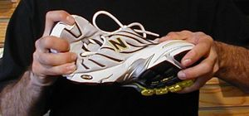
  - There should be minimal torsion movement in your shoe
    - TO TEST: grasp the heel and the front of the shoe near the ball of the foot and twist lengthways.

- Flexibility of front of the shoe
  - The shoe should bend easily at the ball of the foot- if it doesn’t, neither will your foot
  - The shoe should remain stiff in the mid shoe region from the ball of the foot to the heel-this gives more arch stability

- Mid-sole density
  - If you press into the sole of the shoe and it compresses more than a third it may be too soft
    - TO TEST: with your thumbs compress the rubber of the mid-sole
  - A dual-density mid-sole is where the sole on the medial side (where the arch of your foot is) is firmer and where the outer aspect of the mid-sole is softer.
    - These types of shoes are good for athletes whose feet roll inward or flatten
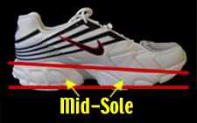

- Heel Counter
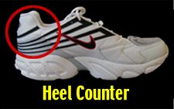
  - The strength of the heel counter is important to keep your heel upright
  - It should be made of plastic, not cardboard as plastic provides more support and lasts longer
Many off the shelf ”netball” shoes lack good support/control aspects important for netball.
Appropriate footwear is important in injury prevention and game performance.
Remember to replace your shoes regularly as they do wear out quickly when being used frequently.
Make sure you wear good quality shoes whenever you play. This includes trainings because you are just as prone to the injuries that occur during games.
If you have questions about your footwear or have any niggly problems please feel free to contact me on (08) 8263 8844. If I am consulting, leave a message and I am more than happy to call you back.

Lisa Crowder
Tango League Physiotherapist
Roberts Physiotherapy

